The VLNETWORK CORPORATE SALES SHEET

For more information:
- (web icon) VLNetwork.com/ContactUS
- (email icon) Sales@VLNetwork.com
- (phone icon)(914)-348-1899

Corresponding to this section:
REVISED CONTENT:
THE VISIONARY LEADER NETWORK provides leadership development and team and culture development through training, events and media collaboration to cultivate Happiness 360.

Corresponding to this section:
REVISED CONTENT (Various Options):
- Building Fearless Listening Leadership Cultures
- Fearless Listening Leadership
- The Future of Leadership
- Building Cultures – One Leader At A Time
- Leading Cultures to Happiness 360
- Happiness 360 – Fearless Listening Leadership
- Leadership & Culture Development
- Safe, Diverse and Inclusive Leadership Cultures
- Connecting through Fearless Listening Leadership
- Connecting, Training, and Leading

Corresponding to this Section
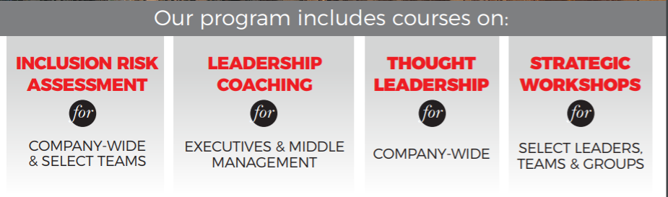
REVISED CONTENT:
Our Services, include training, coaching and events:
Box 1: Leadership Development (Foster Fearless Listening Leadership for personal and professional development)
Box 2: Team & Culture Development (Develop Fearless Listening Teams to create Safe, Diverse and Inclusive Environments)
Box 3: Media Collaboration
Box 4: Our Events

Corresponding to this section
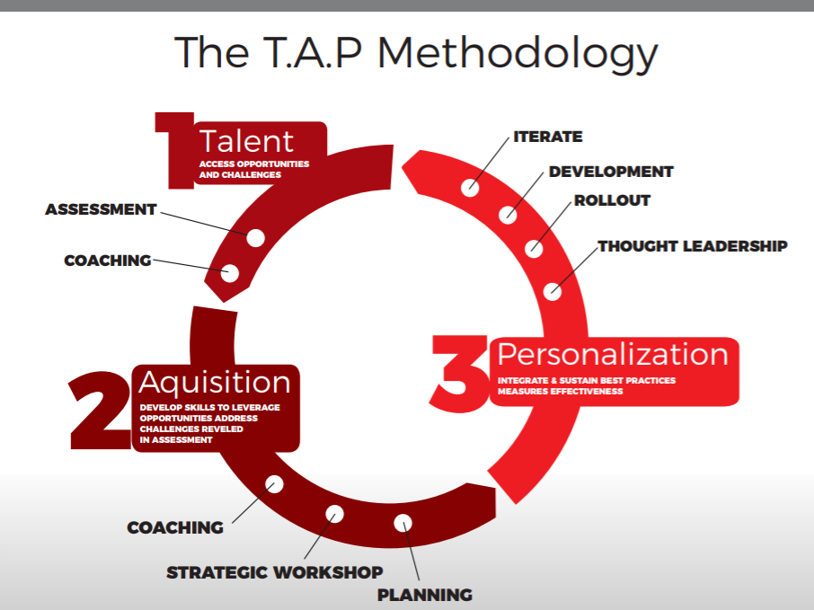

REVISED CONTENT:
Happiness 360 – Fearless Listening Methodology
1. Living Wellness
- Events & Experiences
- Personal Development
  - (Holistic wellness, mindfulness, inner core alignment, deeper connections)
- Purpose and Possibilities
- Foundations of Intelligence
2. Performance & Training
- Leadership Development
  - (Professional development)
- Team & Culture Development
  - (Fearless Listening Leadership Cultures, safe, diverse and inclusive environments)

Corresponding to this Section
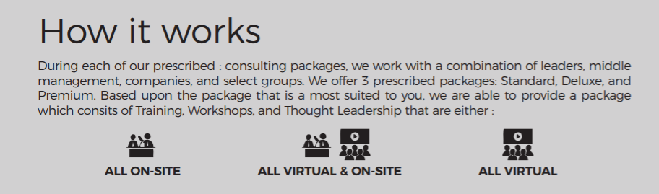
REVISED CONTENT:
The Visionary Leader Network (VLN) is a consulting and training platform that fosters Fearless Listening Leadership Cultures to create Happiness 360 collaboration, productivity and retention by offering best practices to enhance agile leadership and deeper personal connection.
- Training and Courses
- Coaching and Consulting
- Events and Experiences

FOR THIS ILLUSTRATION MAKE THE FOLLOWING CHANGES TO THE TEXT AND ILLUSTRATION
  - GOALS and OUTCOMES (HAPPINESS 360) HOW-- (USING FEARLESS LISTENING) and add accountably and sustainabilityUSE "Sustainability when the circle loops on the chart)
